 

 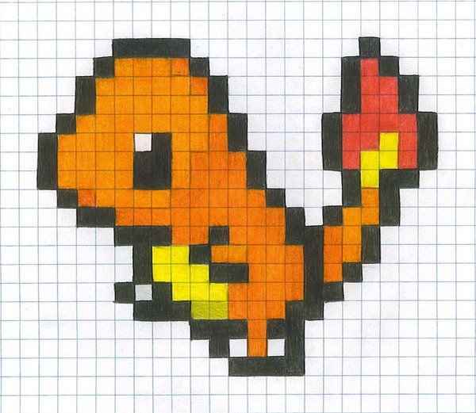

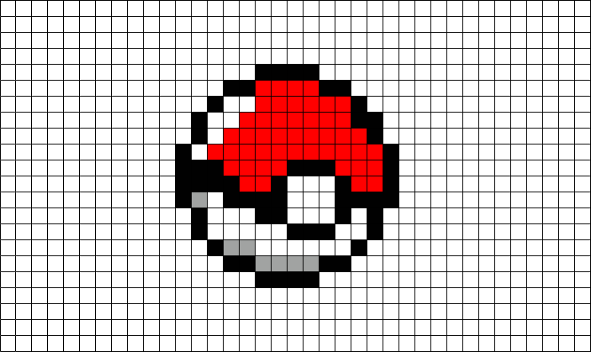 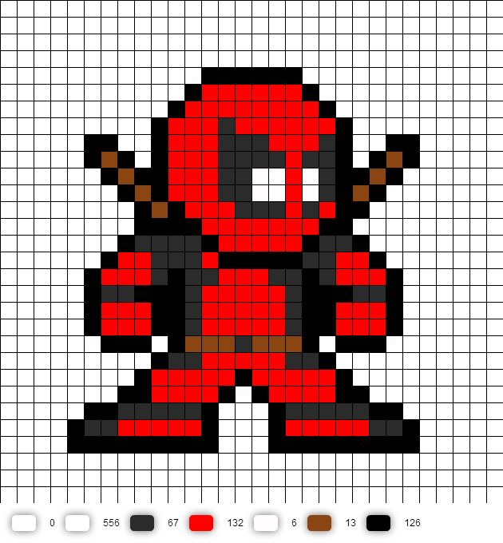

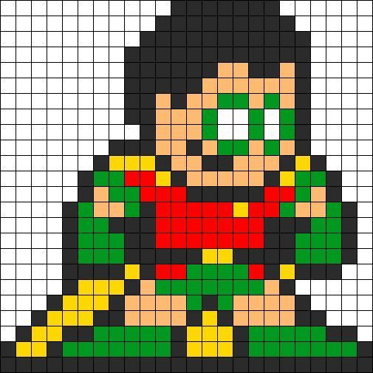 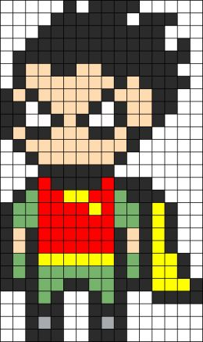 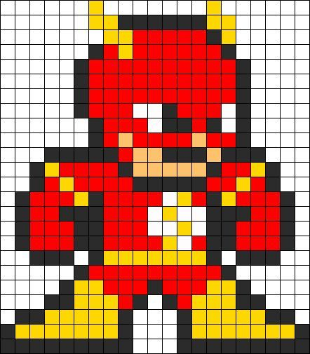

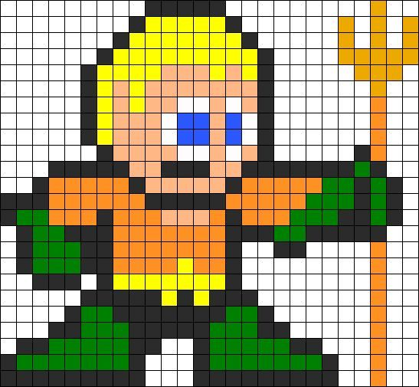 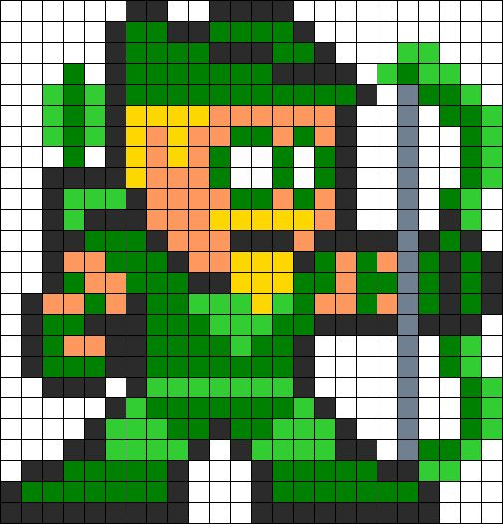 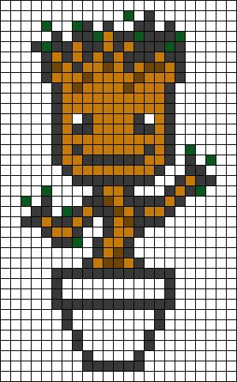

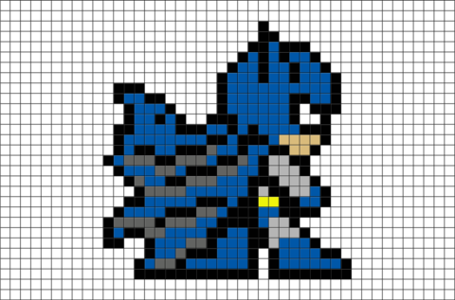 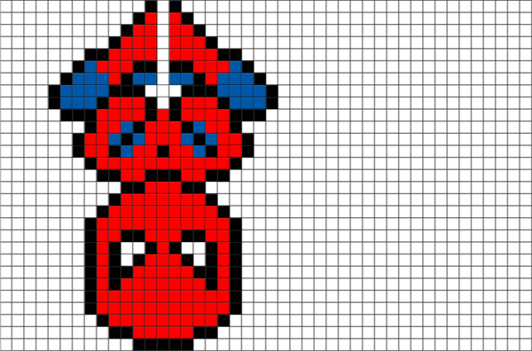 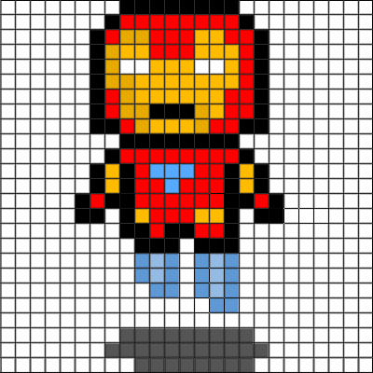

[](https://www.google.es/url?url=https://es.pinterest.com/pin/542402348849546290/&rct=j&frm=1&q=&esrc=s&sa=U&ved=0ahUKEwiXseWspbDUAhWHaFAKHTYEA00QwW4IKDAJ&usg=AFQjCNHH3rmSVGfjr8GB0Z0jiEafCMX0Aw) [](https://www.google.es/url?url=https://www.pinterest.com/explore/easy-pixel-art/&rct=j&frm=1&q=&esrc=s&sa=U&ved=0ahUKEwiXseWspbDUAhWHaFAKHTYEA00QwW4IMDAN&usg=AFQjCNFQkyDsPEiK9NJvnigOR4YU1BHdbA) [](https://www.google.es/url?url=https://www.pinterest.com/explore/minecraft-pixel-art/&rct=j&frm=1&q=&esrc=s&sa=U&ved=0ahUKEwiXseWspbDUAhWHaFAKHTYEA00QwW4IODAR&usg=AFQjCNEDAzM6eNyz8st75qtZGO3PAGcY9w)

[](https://www.google.es/url?url=https://www.youtube.com/watch?v%3DlIUUHMXd4Lc&rct=j&frm=1&q=&esrc=s&sa=U&ved=0ahUKEwirk7DOpbDUAhWPYlAKHfZHA4Q4FBDBbgg2MBA&usg=AFQjCNGR2YXhDjwTQYFRwWlR9QzVBtMy0Q) [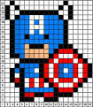](https://www.google.es/url?url=https://www.pinterest.com/explore/easy-pixel-art/&rct=j&frm=1&q=&esrc=s&sa=U&ved=0ahUKEwirk7DOpbDUAhWPYlAKHfZHA4Q4FBDBbggaMAI&usg=AFQjCNFQkyDsPEiK9NJvnigOR4YU1BHdbA) [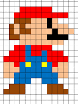](https://www.google.es/url?url=https://minecraftpixelarttemplates.wordpress.com/&rct=j&frm=1&q=&esrc=s&sa=U&ved=0ahUKEwirk7DOpbDUAhWPYlAKHfZHA4Q4FBDBbggiMAY&usg=AFQjCNFTsgCNU_IFHWHYnSR2XFLm2Rn_lQ)

[](https://www.google.es/url?url=https://www.pinterest.com/explore/easy-pixel-art/&rct=j&frm=1&q=&esrc=s&sa=U&ved=0ahUKEwjv3djypbDUAhWGJFAKHfxsDew4KBDBbggWMAA&usg=AFQjCNFQkyDsPEiK9NJvnigOR4YU1BHdbA) [](http://www.google.es/url?url=http://piq.codeus.net/picture/134596/iron_sword_minecraft_&rct=j&frm=1&q=&esrc=s&sa=U&ved=0ahUKEwj4-_CDprDUAhWMJlAKHd6GCN44ZBDBbgguMAw&usg=AFQjCNF0AZaxMCG8uuF1Cl6LC-c-0ErKag) [](http://www.google.es/url?url=http://www.minecraftpixelarttemplates.com/2013/03/hamburger.html&rct=j&frm=1&q=&esrc=s&sa=U&ved=0ahUKEwj4-_CDprDUAhWMJlAKHd6GCN44ZBDBbggqMAo&usg=AFQjCNEl4MYr2xGwroKtcEDXxnxUkAFrSg)

[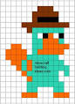](https://www.google.es/url?url=https://es.pinterest.com/pin/558024210060104328/&rct=j&frm=1&q=&esrc=s&sa=U&ved=0ahUKEwj4-_CDprDUAhWMJlAKHd6GCN44ZBDBbggiMAY&usg=AFQjCNFGSZdh6jQEe3ulqmpefZrp-KdIIg) [](https://www.google.es/url?url=https://sites.google.com/a/jeffcoschools.us/ava-j-cms-8/computer-applications/pixel-art&rct=j&frm=1&q=&esrc=s&sa=U&ved=0ahUKEwj4-_CDprDUAhWMJlAKHd6GCN44ZBDBbgg8MBM&usg=AFQjCNFjFNBbvrmT2aISBJhcBWpexxXldg) [](https://www.google.es/url?url=https://www.reddit.com/r/GrandTheftAutoV/comments/2ab1xa/not_sure_how_some_of_you_are_so_good_at_making/&rct=j&frm=1&q=&esrc=s&sa=U&ved=0ahUKEwiTxdShprDUAhXNJlAKHbtcCi44oAEQwW4IIDAF&usg=AFQjCNGIP__5PK3W6994Cmuo_Bj4QxIR0A)